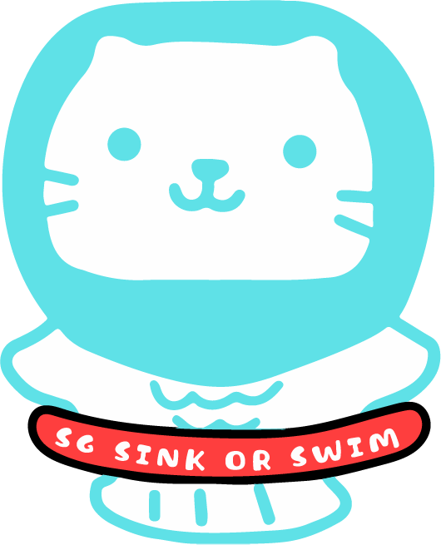

Swim Booklet

Name: ____________________
Start Level: ______ Date: _________

The Water Safety Code - Have Fun, Stay Safe
1.Spot the dangers - Whenever you’re near water always take extra care:
- Never fool around or run besides water – you might trip and fall in
- Take care on the riverbank – it may be slippery and can crumble
- Keep away from the edge of canals – the water is often very deep
- Beware of locks and weirs – the water flows very quickly

2. Take safety advice - To be safe, choose a swimming pool or beach where there are lifeguards:
- Always follow the advice of a lifeguard – find out where and when it is safe to swim
- Look for signs or flags which tell you if it is safe to swim
- Never swim where a sign or flag tells you not to

3. Do not go alone - If you’re alone there will be no-one to help you if you get into trouble in the water
- Never go swimming, fishing or boating on your own
- Go with a friend who can help you if you’re in trouble in difficult water – even if they cannot help you out, they can get help
- Always make sure a grown-up known where you are going and when you will be back

4. Learn how to help - If you see someone in trouble in the water, here’s how you can help:
- Keep calm – always think before you act
- Try to get help – shout ‘’help, help’’ as loud as you can
- Reach out with a stick, a pole, a towel or clothing to pull the person to the water’s edge – always lie down when you are trying to pull someone in so that you don’t get pulled in
- If you can’t reach the person and no-one comes when you shout for help, telephone 995 and ask for help

NEVER JUMP INTO THE WATER YOURSELF!

Nursery
The kids will develop the basic skills needs to keep a float in water and to get ready to start swimming in a fun environment.
Skills | I CAN
1. Enter the water safely
2. I can move through the water (walking,running,jumping…)
3. I can jump in
- with assist
- without assist
4. I can float on my front with aid
5. I can float on my back with aid
6. I can roll over
7. I can blow bubbles
8. I can move forward with aid for a distance of 3 meters
9. I can move backwords with aid for a distance of 3 meters
10. I can enter, turn, return (swallow pool)
11. I can exit safely

Notes ………………………………………………………………………………………………………………………………………
………………………………………………………………………………………………………………………………………
…………………………………………………………………………………………………………………………..

Level 1
Skills | I CAN
1. Enter the water safely - slide in entry
2. Scoop the water and wash face
3. Be at ease with water showered from overhead
4. Exhale in water
- Mouth touch the water and exhale
- Nose touch the water and exhale
- Face in water to hairline and exhale
5. Submerge
- Open eyes under water and exhale
6. Move into a stretched floating position using aids,equipment or support
- sit and push or push from the wall
7. Regain an upright position from on the back with support
- tuck legs in order to stand
8. Regain an upright position from on the front with support
- tuck legs in order to stand
9. Push and glide in a horizontal position to or from a wall
- straight arms - arms behind the ears, like an arrow position
- legs straight - toes pointed
10. Demonstrate an understanding of pool rules
11. Exit the water safely,
The swimmer should and will develop basic movement skills, water confidence and safety awareness. Don’t forget the swimmers will be able to use aids
Level 2
During Level 2, swimmers will develop safe entries to the water and will continue to practice floating, travel and rotation in the water. Remember swimmers can still use aids e.g. arm bands and floats to help complete this stage.
Skills | I CAN
1. Jump in from poolside safely
- feet first
2. Blow bubbles a minimum of three times rhythmically with nose and mouth submerged
3. Regain upright position from the back without support
- tuck legs
4. Regain an upright position from the front without support
- tuck legs
5. Push from wall and glide on the back and recover
- straight arms - arms behind the ears, like an arrow position
- legs straight, toes pointed and closed together
- eyes and chin facing up
6. Push from wall and glide on the front and recover
- straight arms - arms behind the ears, like an arrow position
- legs must be straight and together after the push
7. Perform a rotation from the front to the back to gain and upright position
- log roll
8. Perform a rotation from the back to the front to gain and upright position
- log roll

Level 3
During Level 3, swimmers work towards being able to swim 10m on their front and back and will be able to swim underwater to collect objects from the bottom of the pool. Rotation skills and water safety knowledge will also be developed.
Skills | I CAN
1. Jump in from poolside and submerge (min depth 0.9 metres)
- feet first
2. Sink, push away from wall on side and maintain a streamlined position
- straight arms - arms above the ears, like an arrow position
- legs must be straight and together after the push, toes pointed
3. Push and glide on the front with arms extended and log roll onto the back
- arms either on the side or in front
4. Push and glide on the back with arms extended and log roll onto the front
- arms either on the side or in front
5. Travel on the front, tuck to rotate around the horizontal axis to return on the back.
- tuck the chin- forehead to knees - tuck the legs
6. Fully submerge to pick up an object from the pool floor (depth 0.9-1.2m)
7. Answer correctly the questions on the Water Safety Code
8. Travel 10 metres on the back - arms extended (Backstroke)
9. Travel 10 metres on the front- arms extended (Freestyle)

Level 4
In Level 4 swimmers will focus on refining kicking techniques for all four strokes and develop a better understanding of buoyancy.
Skills | I CAN
1. Demonstrate an understanding of buoyancy through demonstrating:
- Perform a tuck float for 5 seconds
- Perform a starf float float on front and back for 5sec
- Float in a streamlined position on front and back for 5 sec
2. Perform a sequence of changing shapes (three) whilst floating at the surface
3. Push and glide from the wall to the pool floor
4. Kick 10 metres backstroke (equipment optional)
- legs straight with pointed toes and kick small
5. Kick 10 metres front crawl (equipment optional)
- legs straight with pointed toes and kick small
6. Kick 10 metres butterfly on the front or on the back
- kicking simultaneously, keeping the legs together
7. Kick 10 metres breaststroke on the front (equip. optional)
- kicking (a) heels to butt, (b) feet flexed (c) kick out to star (d) squeeze knees to streamline
- legs must be togther and straight after the kick with pointed toes
8. Perform on the back a head first sculling action for 5 metres in a horizontal position
- arms on the side, fingers pointing up and performing a wave action
9. Travel on back & roll in 1 continuous movement onto front - log roll
10. Travel on front & roll in 1 continuous movement onto back - log roll
11. Swim 10 metres, choice of stroke is optional

Level 5
In Level 5 swimmers will focus on swimming all four strokes. Swimmers will also develop skills in sculling, treading water and complete rotation.
Skills | I CAN
1. Perform a horizontal stationary scull on the back
2. Perform a feet first sculling action for 5 metres whilst horizontal on the back
- arms on the side, fingers slightly pointing down and performing a wave action
3. Perform a sculling sequence with a partner for 30-45 seconds to include a rotation
4. Tread water for 30 seconds
- doing bicycle kick and/or eggbeater holding or hugging a board
5. Perform three different shaped jumps into deep water
6. Swim 10 metres backstroke
- straight arms alternate rotation
- legs kicking continuously with straight legs and pointed toes (knees not to break surface)
7. Swim 10 metres front crawl face in the water
- (a) arms alternate rotation (b) legs kicking continuously with straight legs and pointed toes
8. Swim 10 metres breaststroke
- rhythm pull- breathe- kick
9. Swim 10 metres butterfly
- head enters water before hands; thumbs down on recovery (arms swinging over the water)
10. Perform a handstand and hold for a min of 3 sec
11. Perform a forward somersault, tucked, in the water
- tuck the chin- forehead to knees - tuck the legs

Level 6
During Level 6, swimmers will focus on developing effective swimming skills including co-ordinated breathing, water safety and an understanding of how to prepare for exercise.
Skills | I CAN
1. Sink, push off on side from the wall, glide, 6 streamline kicks and rotate into backstroke
- straight arms- arms behind the ears, like an arrow position
- legs must be together while performing the kick
2. Sink, push off on side from the wall, glide, 6 streamline kicks and rotate into front crawl
- straight arms- arms behind the ears, like an arrow position
- legs must be together while performing the kick
3. Swim 10,15, 25m wearing clothes
4. Swim front crawl to include at least six rhythmical breaths
- breathe every 2 strokes
5. Swim breaststroke to include at least six rhythmical breaths
- pull-breathe -kick
6. Swim butterfly to include at least 4,6,8 rhythmical strokes / breaths
- kick hands in - kick hands out & breathe
- legs must kick at the same time
7. Swim 25 metres freestyle and backstroke
8. Perform a ‘shout and signal’ rescue
9. Perform a surface dive

